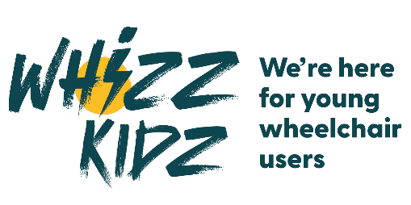

IMMEDIATE RELEASE
Date: 05/03/25

Local [City/Town] Resident to Run London Marathon, Supporting Whizz Kidz

[Local Person's Name], a resident of [City/Town], will be lacing up their running shoes to participate in the iconic London Marathon. Not only aiming to conquer the gruelling 26.2-mile course, but [Local Person's Name] is also on a mission to raise vital funds for the renowned charity, Whizz Kidz.

Whizz Kidz is a national charity that provides disabled children and young people with vital mobility equipment, and training to help them gain skills and look forward to a bright future. An estimated 75,000 young people in the UK need a wheelchair to be mobile, yet many do not have access to a chair that fully meets their needs. Without the right wheelchair, young people can face social isolation, mental health challenges, physical pain, and limited independence. Whizz Kidz is committed to ensuring every young wheelchair user has access to the mobility and support they deserve.

Runner’s Name], [age if relevant], is taking on the iconic 26.2-mile challenge to help change the lives of young wheelchair users across the UK. [He/She/They] is aiming to raise £[Fundraising Goal], which will contribute towards providing life-changing wheelchairs, equipment, and confidence-building services for children and young people. By undertaking this significant challenge, they are not only pushing their own physical limits but also making a tangible difference in the lives of young wheelchair users across the UK.

In preparation for the marathon, [Local Person's Name] has been tirelessly training, dedicating countless hours to ensure they are ready to tackle the demanding course through the streets of London. Their commitment to excellence in both their athletic pursuits and charitable endeavour’s is truly commendable.

Speaking about their motivation for taking part in this challenge, [Local Person's Name] expressed their passion for supporting Whizz Kidz and making a positive impact in their community. They emphasised the importance of ensuring that every child, regardless of their abilities, has access to the support and resources they need to thrive.

[Quote from Local Person's Name about their motivation and goals]

Sarah Pugh, CEO at Whizz Kidz, said:
"We are so grateful to [Runner’s Name] for taking on this huge challenge for Whizz Kidz. Every mile run and every pound raised makes a real difference to young wheelchair users, helping them gain the mobility and confidence to live life to the fullest. We’ll be cheering them on every step of the way!"

The London Marathon is one of the world's most prestigious races, and [Runner’s Name] is calling on the local community to support their fundraising efforts. Donations can be made via [Runner’s Fundraising Page Link].

For further information, please visit Whizz Kidz's website.

ENDS

For Media enquiries, please contact Senior Media & PR Manager Andie Hill at a.hill@whizz-kidz.org.uk 07776956062

For more information, visit www.whizz-kidz.org.uk
Follow @WhizzKidz on Twitter and Facebook // @whizzkidzuk on Instagram // Whizz-Kidz on LinkedIn

About Whizz Kidz

As the UK’s leading charity for young wheelchair users, we empower young people by providing the wheelchairs, equipment, support and confidence-building experiences they need, and campaigning for a more inclusive society. Our vision is a society in which every young wheelchair user is mobile, enabled and included.

About young wheelchair users in the UK
• An estimated 75,000 young people in the UK need a wheelchair to be mobile.
• Most young people aren’t getting a wheelchair that fully meets their needs through local services
• For a young person, having the wrong wheelchair can lead to dependence on others, social isolation, poor mental health, pain and injury.
• Without the ability to be independent young wheelchair users are restricted in their ability to socialise and participate in society.

