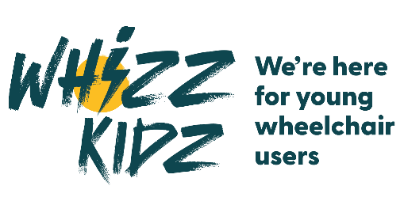

IMMEDIATE RELEASE
Date: 08/10/25

[Local Person’s Name] Laces Up for 2026 London Marathon to Help Whizz Kidz Smash £1 Million Fundraising Goal

[City/Town], [Date] — Trainers are tied, playlists are ready, and the countdown is on — [Local Person’s Name] from [City/Town] is gearing up to hit the streets of London for the 2026 TCS London Marathon, running to raise vital funds for Whizz Kidz and help the charity smash its record-breaking £1 million fundraising total from last year.

In 2025, Whizz Kidz runners collectively raised more than £1 million to help provide life-changing wheelchairs, mobility equipment, and opportunities for young wheelchair users across the UK. This year, 425 runners will take on the challenge for Whizz Kidz — and [Local Person’s Name] is determined to help the team go the distance and raise even more.

[Quote from Local Person's Name about their motivation and goals]
“[Insert quote from Local Person’s Name, e.g. ‘Every mile I run is for a child who deserves the freedom to move,’ said [Local Person’s Name]. ‘If we can beat last year’s total, we’ll help even more young people cross their own finish lines in life.’]”

With months of training behind them and race day in sight, [Local Person’s Name] is ready to push through every mile marker, heart pounding and legs burning, to make every stride count. They’ve set a personal fundraising target of [Insert Amount] — and they’re calling on local supporters to help them sprint past the finish line.

Whizz Kidz is the UK’s leading charity for young wheelchair users, giving children and young people the right mobility equipment, skills, and confidence to live independently. With around 75,000 young people across the UK needing a wheelchair — and many still without one that meets their needs — every donation fuels real change.

So, as the Whizz Kidz marathon team takes to the start line, let’s cheer them on as they power through 26.2 miles for a brighter, more inclusive future — one stride, one mile, one life-changing wheelchair at a time.

Support [Local Person’s Name] and the Whizz Kidz marathon team at [Insert Fundraising Link]. Together, let’s run toward another record-breaking year.

For further information, please visit Whizz Kidz's website.

ENDS

For Media enquiries, please contact Senior Media & Communications Manager Andie Hill at a.hill@whizz-kidz.org.uk 07776956062

For more information, visit www.whizz-kidz.org.uk
Follow @WhizzKidz on Twitter and Facebook // @whizzkidzuk on Instagram // Whizz-Kidz on LinkedIn

About Whizz-Kidz

As the UK’s leading charity for young wheelchair users, we empower young people by providing the wheelchairs, equipment, support and confidence-building experiences they need, and campaigning for a more inclusive society. Our vision is a society in which every young wheelchair user is mobile, enabled and included.

About young wheelchair users in the UK
• An estimated 75,000 young people in the UK need a wheelchair to be mobile.
• Most young people aren’t getting a wheelchair that fully meets their needs through local services
• For a young person, having the wrong wheelchair can lead to dependence on others, social isolation, poor mental health, pain and injury.
• Without the ability to be independent young wheelchair users are restricted in their ability to socialise and participate in society.

